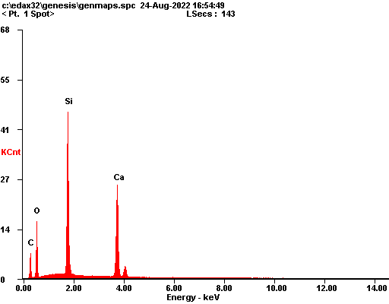

|  |  |  |
| --- | --- | --- |
| ***Element*** | ***Wt%*** | ***At%*** |
| ***CK*** | 14.73 | 26.42 |
| ***OK*** | 27.15 | 36.56 |
| ***SiK*** | 25.20 | 19.33 |
| ***CaK*** | 32.92 | 17.69 |
| ***Matrix*** | Correction | ZAF |

